The owner of this document Darren Cosgrave

Student number B00067349

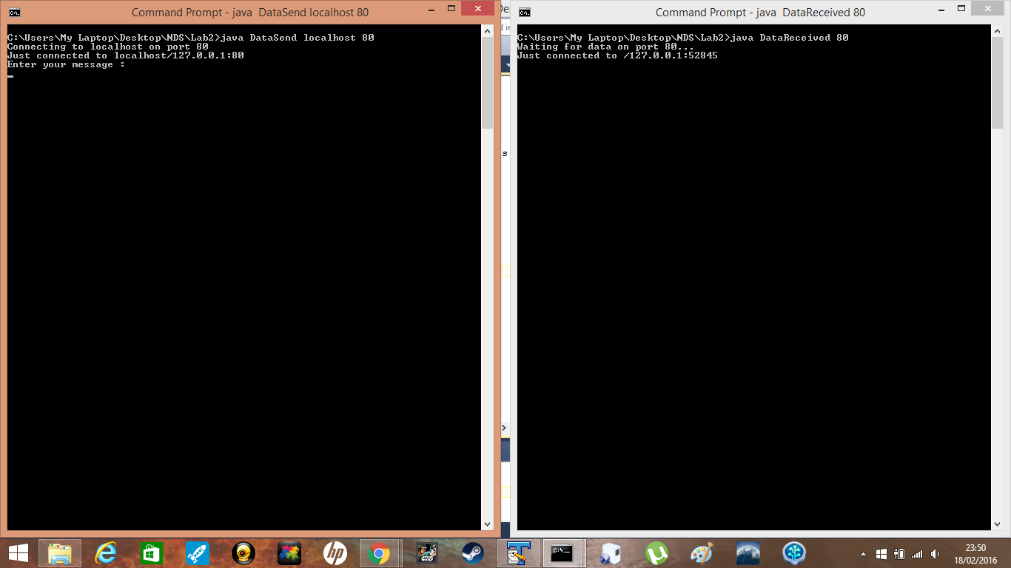

So as you can see I have the program waiting for the user to input a value and the receiver is in wait mode.

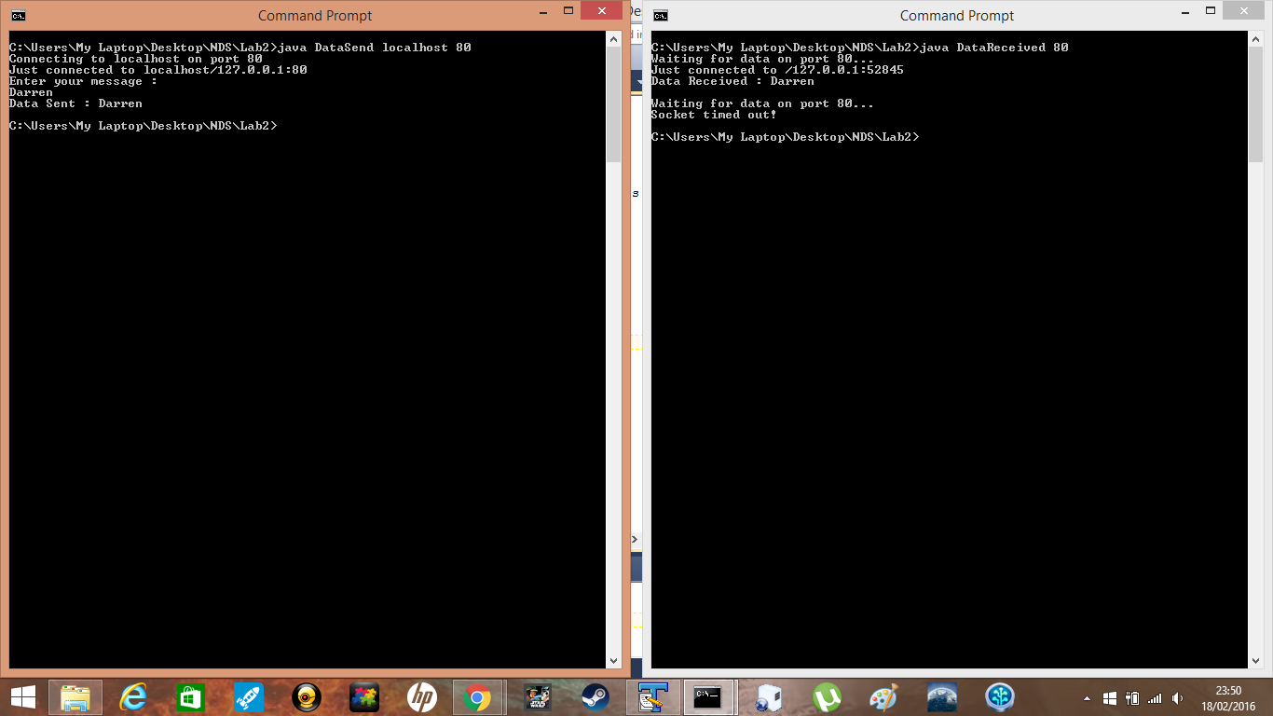

When the user hits enter it sends the value to the receiver and prints on the receiver side. When the receiver doesn’t revive new data it will kill the connection.

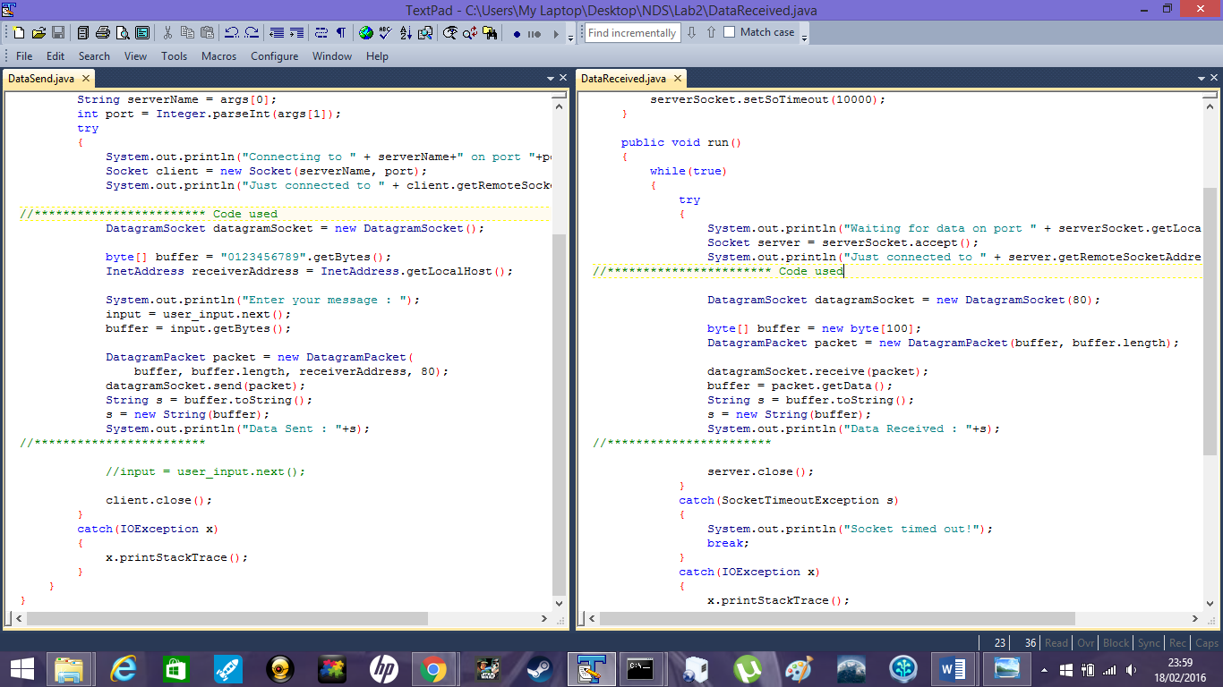

The code used to achieve the above result on both sides.